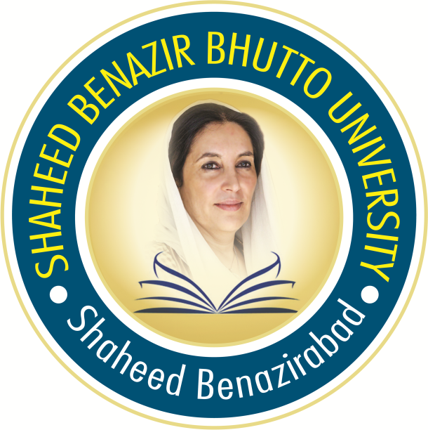

PAKISTAN STUDY

Pakistan Study
B.A, B.Sc, B.Com

Paper-II
- IDEOLOGY OF PAKISTAN
Creation of Pakistan aims and objectives
Ideology of Pakistan:
- Definition
- Ideology of Pakistan in the light of views of Allama Iqbal and Quide Azam

- IDEOLOGY OF PAKISTAN:
HISTORICAL PERSPECTIVE
- National reformation Movements (Saikh sarhand) shah Waliullah and afterwards)
- Educational Efforts ( Aligrah , Devband , Nidwah, Anjumun, Himayat ul Islam and other local educational institutions, Sindh Madrsah, Islamia College Peshawar)
- Political Struggle :
- Constitutional reforms and Muslim , separate electorate
- Khilafat Movement.

- PAKISTAN MOVEMENT
- Muslim National / Evolution of two nation theory
- The Question of Independence of India and the role of Muslims
- Address of Allama Aqbal at allah abad
- The Election of 1937and attitude of congress ministries.
- Pakistan resolution
- 1946 Election and the transfer of power.

- THE CREATION OF PAKISTAN
Initial difficulties and important events.

- EFFORTS TO IMPLEMENT ISLAMIC SYSTEM IN PAKISTAN.
- Objective Resolution
- Islamic Provision of 1956, 1962 and 1973 constitutions
- Various steps to enforce shariah
- Our Goal Establishment of perfect Islamic society

- THE LAND OF PAKISTAN
- Geoghraphical unity , Location , Geographical Importance , Urban and Rural areas
- National Resources
- 3.Agriculture
- Industry
- Man Power (Education)

- PAKISTAN AND THE MUSLIM WORLD

